**Experiment No – 1**

**CODE**

activity_main.xml

<?xml version="1.0" encoding="utf-8"?>

<LinearLayout xmlns:android="http://schemas.android.com/apk/res/android"

xmlns:app="http://schemas.android.com/apk/res-auto"

xmlns:tools="http://schemas.android.com/tools"

android:layout_width="match_parent"

android:layout_height="match_parent"

tools:context=".MainActivity"

android:orientation="vertical"

android:gravity="center">

<EditText

android:layout_width="wrap_content"

android:layout_height="wrap_content"

android:id="@+id/username"

android:hint="enter_your_username_capitalised_name"

android:inputType="text" />

<EditText

android:layout_width="wrap_content"

android:layout_height="wrap_content"

android:id="@+id/pswd"

android:hint="enter_your_password_bit"

android:inputType="textPassword" />

<LinearLayout

android:layout_width="wrap_content"

android:layout_height="wrap_content"

android:orientation="horizontal">

<TextView

android:layout_width="wrap_content"

android:layout_height="wrap_content"

android:text="number_of_tries_left"

app:layout_constraintBottom_toBottomOf="parent"

app:layout_constraintLeft_toLeftOf="parent"

app:layout_constraintRight_toRightOf="parent"

app:layout_constraintTop_toTopOf="parent" />

<TextView

android:layout_width="wrap_content"

android:layout_height="wrap_content"

android:id="@+id/tries_left"/>

</LinearLayout>

<Button

android:layout_width="wrap_content"

android:layout_height="wrap_content"

android:id="@+id/submit"

android:text="submit"/>

</LinearLayout>

MainActivity.java

package com.example.login_application_exp1;

import androidx.appcompat.app.AppCompatActivity;

import android.os.Bundle;

import android.view.View;

import android.widget.Button;

import android.widget.EditText;

import android.widget.TextView;

import android.widget.Toast;

public class MainActivity extends AppCompatActivity {

EditText userName, pswd;

int triesLeft = 3;

TextView maxTry;

Button submitButton;

private final String CORRECT_UNAME = "VinitMasrani";

private final String CORRECT_PSWD = "Pass";

@Override

protected void onCreate(Bundle savedInstanceState) {

super.onCreate(savedInstanceState);

setContentView(R.layout.activity_main);

submitButton = findViewById(R.id.submit);

userName = findViewById(R.id.username);

pswd = findViewById(R.id.pswd);

maxTry = findViewById(R.id.tries_left);

maxTry.setText(String.valueOf(triesLeft));

submitButton.setOnClickListener(new View.OnClickListener() {

@Override

public void onClick(View view) {

String uname = userName.getText().toString();

String password = pswd.getText().toString();

if(uname.equals(CORRECT_UNAME) && password.equals(CORRECT_PSWD))

Toast.makeText(MainActivity.this, "Login Successful", Toast.LENGTH_SHORT).show();

else {

if(triesLeft < 2){

Toast.makeText(MainActivity.this, "No more tries left, relaunch the application and try again.", Toast.LENGTH_SHORT).show();

finish();

}

else

maxTry.setText(String.valueOf(--triesLeft));

}

}

});

}

}

**Output :**

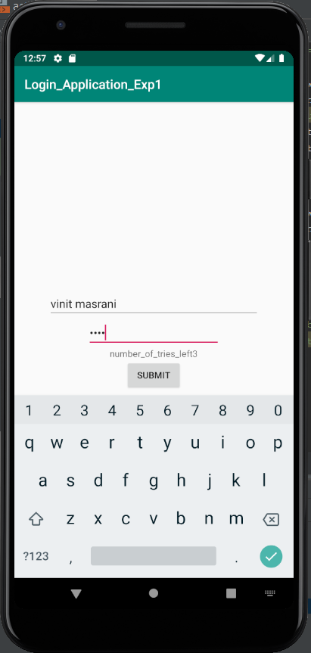

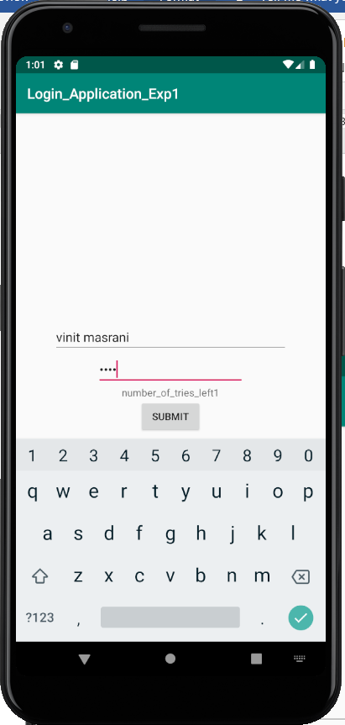

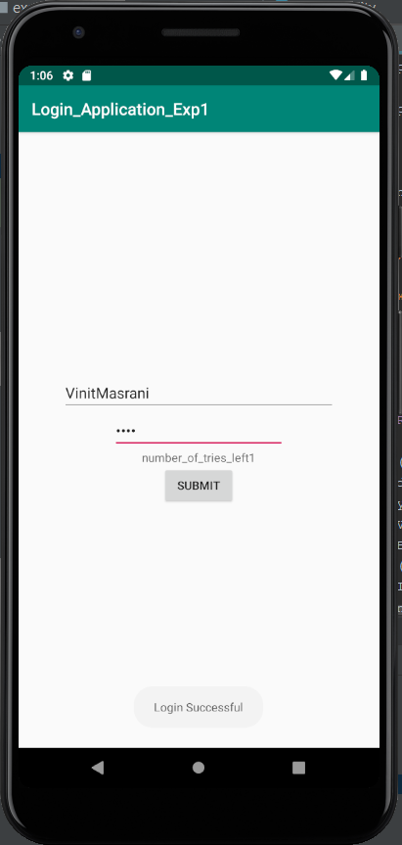

**Conclusion :**

In this experiment we learnt about the various basics of android studio and started the android studio with basic GUI Component Project which was developing Login page.